**20MCA136-NETWORKING & SYSTEM ADMINISTRATION LAB**

**RECORD**

KARTHIKA C BABU

RMCA-B S2

ROLL NO: 07

BASIC LINUX COMMANDS

1. pwd

**pwd** stands for Print Working Directory. It prints the path of the working directory, starting from the root.

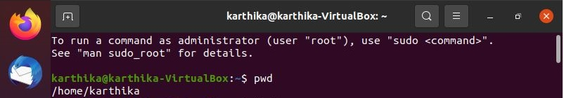

1. history

In **Linux**, there is a very useful **command** to show all of the last **commands** that have been recently used. The **command** is simply called **history.**



1. man

***man*** command in Linux is used to display the user manual of any command that we can run on the terminal. It provides a detailed view of the command which includes NAME, SYNOPSIS, DESCRIPTION, OPTIONS, EXIT STATUS, RETURN VALUES, ERRORS, FILES, VERSIONS, EXAMPLES, AUTHORS and SEE ALSO.

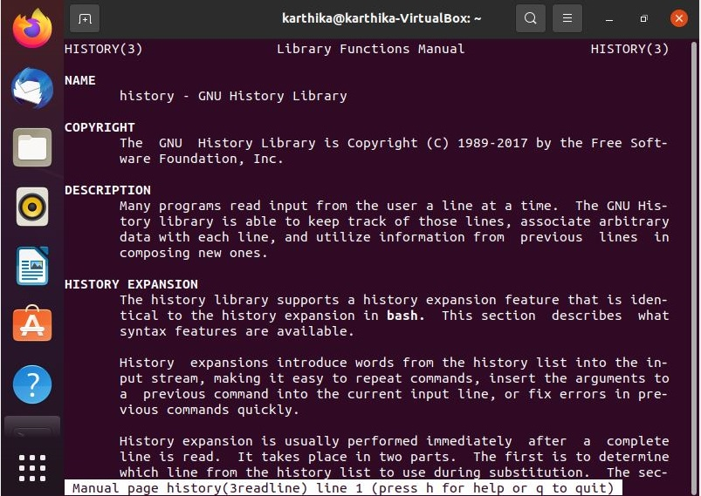

1. cd

The cd (“change directory”) command is used to change the current working directory in Linux and other Unix-like operating systems. It is one of the most basic and frequently used commands when working on the Linux terminal. The current working directory is the directory (folder) in which the user is currently working in. Each time you interact with your command prompt, you are working within a directory.

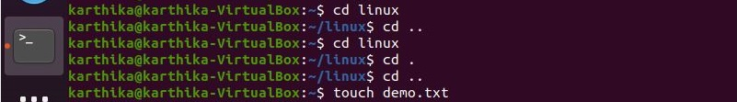

1. ls

The **ls command** is one of the basic **commands** that any Linux user should know. It is used to list information about files and directories within the file system. The **ls** utility is a part of the GNU core utilities package which is installed on all Linux distributions.



1. mkdir

**mkdir** command in Linux allows the user to create directories (also referred to as folders in some operating systems ). This command can create multiple directories at once as well as set the permissions for the directories. It is important to note that the user executing this command must have enough permissions to create a directory in the parent directory, or he/she may recieve a ‘permission denied’ error.



1. rmdir

**rmdir** command is used remove empty directories from the file system in Linux. The **rmdir** command removes each and every directory specified in the **command** line only if these directories are empty. So if the specified directory has some directories or files in it then this cannot be removed by **rmdir** command.

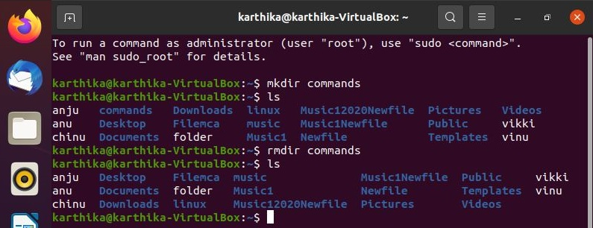

1. touch

The ***touch*** command is a standard command used in UNIX/Linux operating system which is used to create, change and modify timestamps of a file. Basically, there are two different commands to create a file in the Linux system which is as follows:

* **cat command:** It is used to create the file with content.
* **touch command:** It is used to create a file without any content. The file created using touch command is empty. This command can be used when the user doesn’t have data to store at the time of file creation.

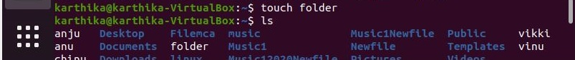

1. rm

rm stands for **remove** . rm command is used to remove files.

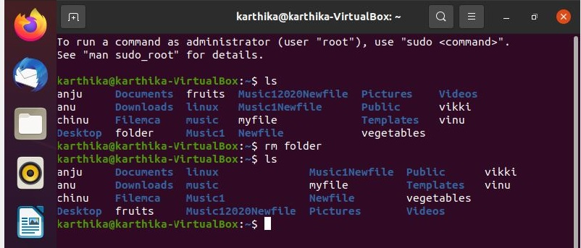

1. cat

The cat command is one of the most widely used commands in Linux. The name of the cat command comes from its functionality to con**cat**enate files. It can read, concatenate, and write file contents to the standard output.

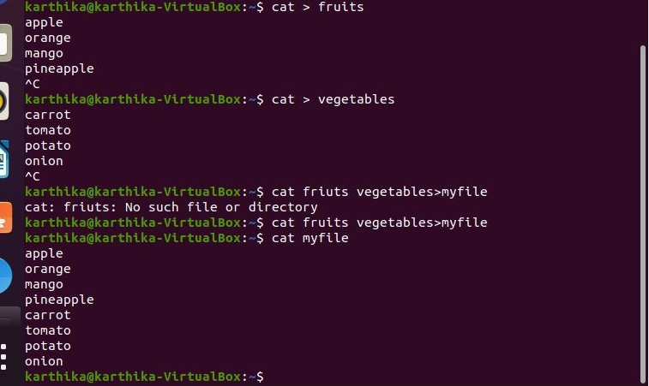

BASIC LINUX COMMANDS

1. echo

**echo command in linux** is used to display line of text/string that are passed as an argument . This is a built in **command** that is mostly used in shell scripts and batch files to output status text to the screen or a file.

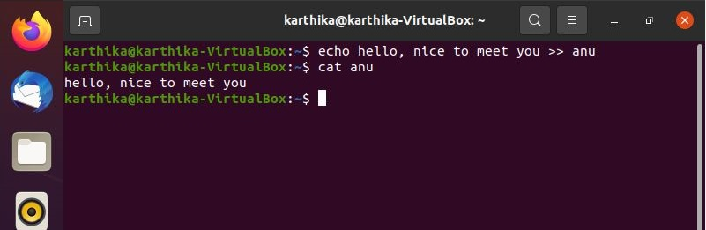

1. head

It is the complementary of Tail command. The head command, as the name implies, print the top N number of data of the given input. By default, it prints the first 10 lines of the specified files. If more than one file name is provided then data from each file is preceded by its file name.

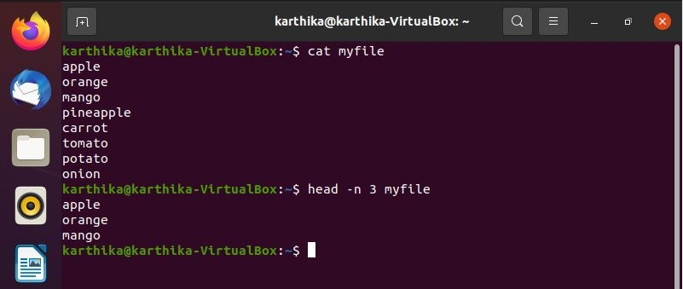

1. tail

It is the complementary of head command. The tail command, as the name implies, print the last N number of data of the given input. By default it prints the last 10 lines of the specified files. If more than one file name is provided then data from each file is precedes by its file name.

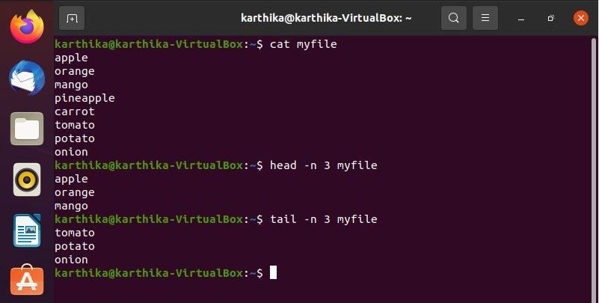

1. read

Read command in Linux system is used to read from a file descriptor. Basically, this command read up the total number of bytes from the specified file descriptor into the buffer. If the number or count is zero then this command may detect the errors. But on success, it returns the number of bytes read.

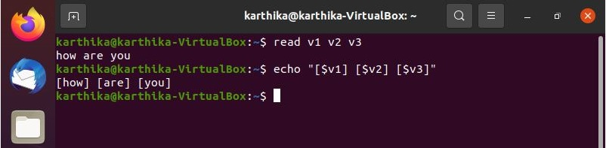

1. more

**more** command is used to view the text files in the command prompt, displaying one screen at a time in case the file is large (For example log files). The more command also allows the user do scroll up and down through the page. The syntax along with options and command is as follows. Another application of more is to use it with some other command after a pipe. When the output is large, we can use more command to see output one by one.

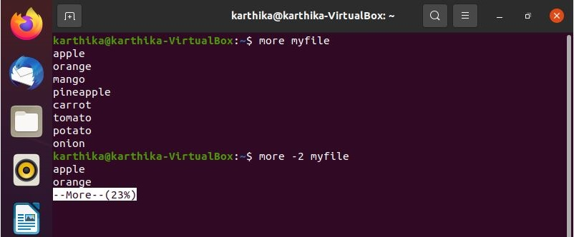

1. less

Less command is linux utility which can be used to read contents of text file one page (one screen) per time. It has faster access because if file is large, it don’t access complete file, but access it page by page.

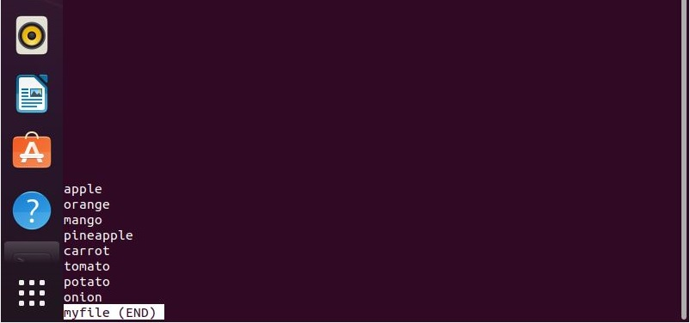

1. cut

The cut command in UNIX is a command for cutting out the sections from each line of files and writing the result to standard output. It can be used to cut parts of a line by **byte position, character and field**. Basically the cut command slices a line and extracts the text. It is necessary to specify option with command otherwise it gives error. If more than one file name is provided then data from each file is **not precedes** by its file name.

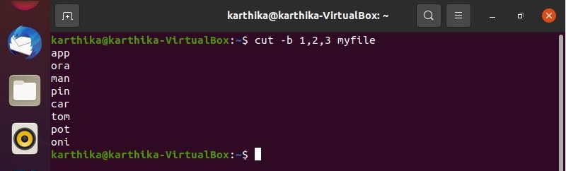

1. paste

Paste command is one of the useful commands in Unix or Linux operating system. It is used to join files horizontally (parallel merging) by outputting lines consisting of lines from each file specified, separated by **tab** as delimiter, to the standard output. When no file is specified, or put dash (“-“) instead of file name, paste reads from standard input and gives output as it is until a interrupt command **[Ctrl-c]** is given.

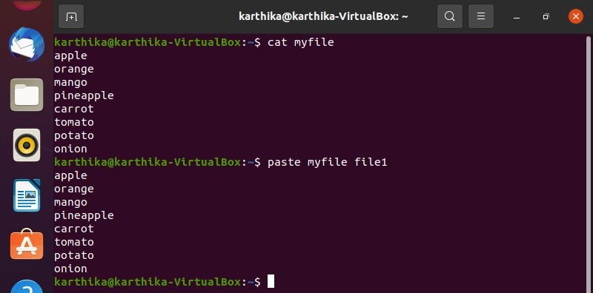

1. uname

The **uname** tool is most commonly used to determine the processor architecture, the system hostname and the version of the kernel running on the system.

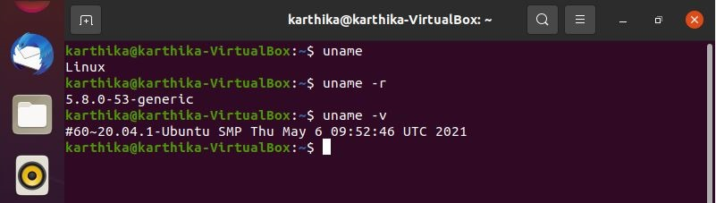

1. cp

**cp** stands for **copy**. This command is used to copy files or group of files or directory. It creates an exact image of a file on a disk with different file name. cp command require at least two filenames in its arguments.

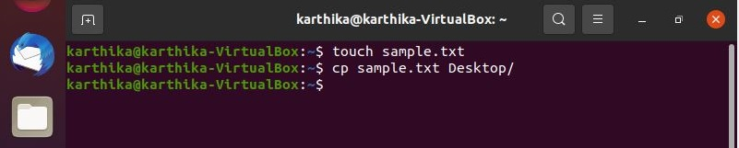



1. mv

**mv** stands for **move**. mv is used to move one or more files or directories from one place to another in a file system like UNIX. It has two distinct functions:   
**1.** It renames a file or folder.   
**2.** It moves a group of files to a different directory.   
No additional space is consumed on a disk during renaming. This command normally **works silently** means no prompt for confirmation.

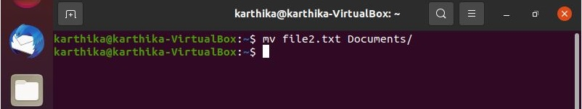



1. locate

The locate command and find command is used to search a file by name. But, the difference between both commands is that locate command is a background process and searches the file in the database whereas, find command searches in the filesystem. The locate command is much faster than find command.

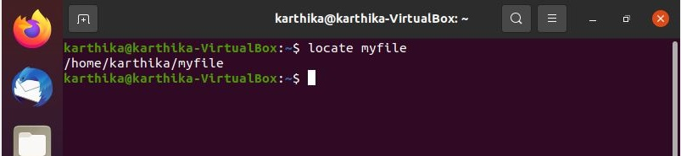

1. find

The **find** command in UNIX is a command line utility for walking a file hierarchy. It can be used to find files and directories and perform subsequent operations on them. It supports searching by file, folder, name, creation date, modification date, owner and permissions. By using the ‘-exec’ other UNIX commands can be executed on files or folders found.

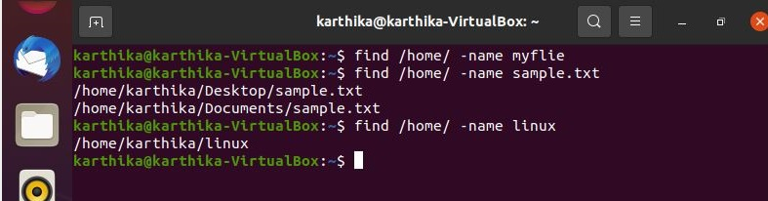

1. grep

The grep filter searches a file for a particular pattern of characters, and displays all lines that contain that pattern. The pattern that is searched in the file is referred to as the regular expression (grep stands for globally search for regular expression and print out).

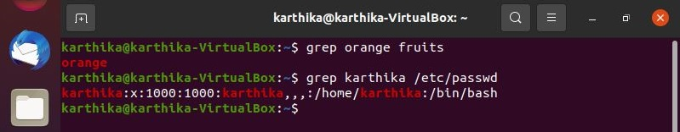

1. df

**Linux df command** is used to display the disk space used in the file system. The '**df**' stands for "disk filesystem." It defines the number of blocks used, the number of blocks available, and the directory where the file system is mounted.

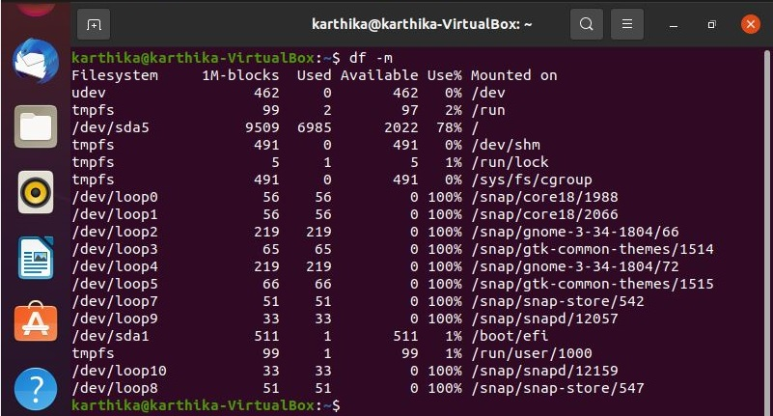

1. du

The **du command** is a standard **Linux**/Unix **command** that allows a user to gain disk usage information quickly. It is best applied to specific directories and allows many variations for customizing the output to meet your needs.

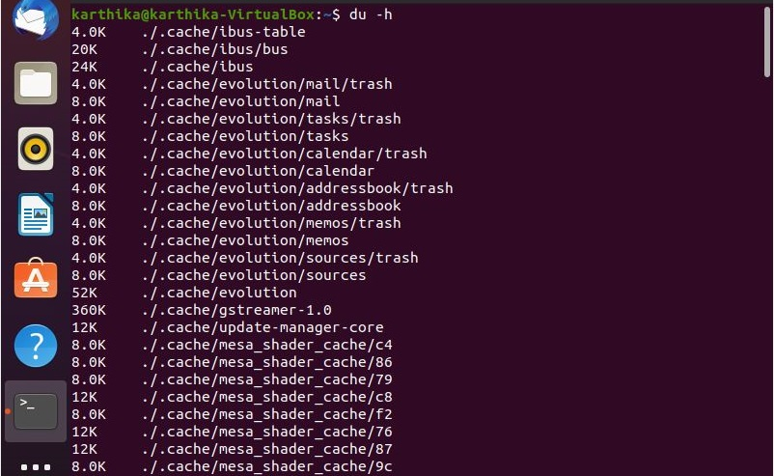

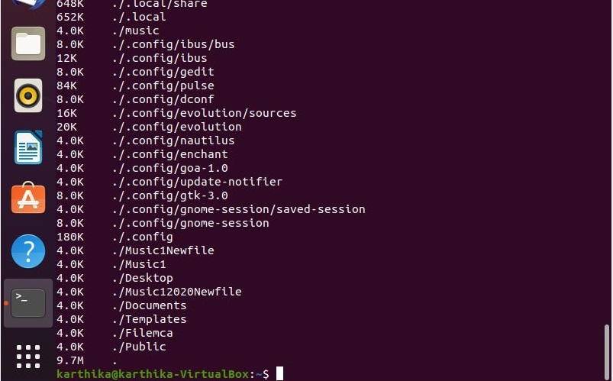

1. useradd

Create a new user or update default new user information.

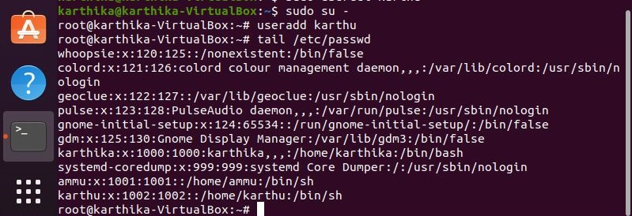

1. userdel

Delete a user account and related files.

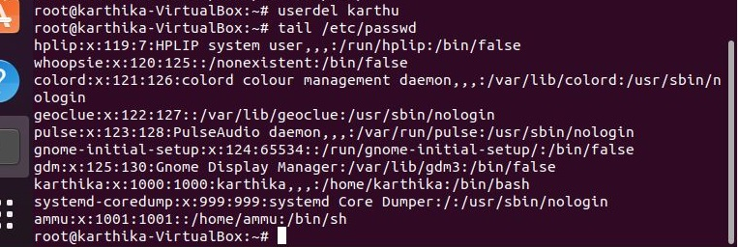

1. sudo

The sudo command allows you to run programs with the security privileges of another user (by default, as the superuser). It prompts you for your personal password and confirms your request to execute a command by checking a file, called sudoers, which the system administrator configures.

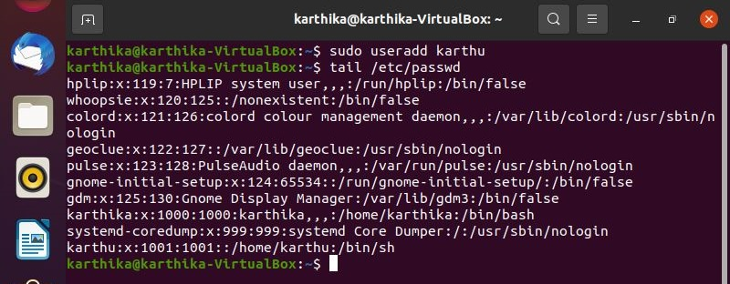

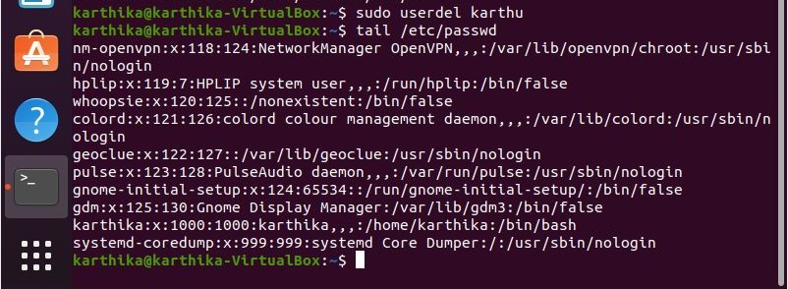

1. passwd

The passwd command changes passwords for user accounts. A normal user may only change the password for their own account, while the superuser may change the password for any account. passwd also changes the account or associated password validity period.

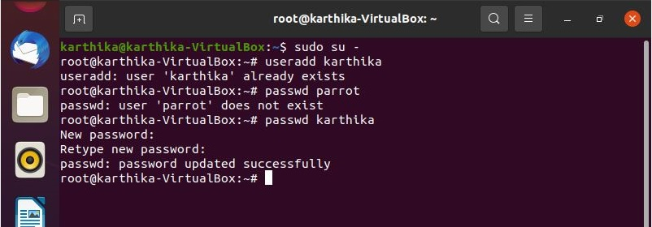

BASIC LINUX COMMANDS

1. usermode

usermod command or modify user is a command in Linux that is used to change the properties of a user in Linux through the command line. After creating a user we have to sometimes change their attributes like password or login directory etc. so in order to do that we use the Usermod command.

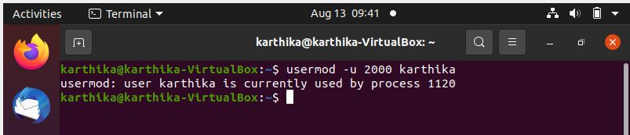

1. groupadd

**groupmod** command in Linux is used to modify or change the existing group on Linux system. It can be handled by superuser or root user. Basically, it modifies a group definition on the system by modifying the right entry in the database of the group.

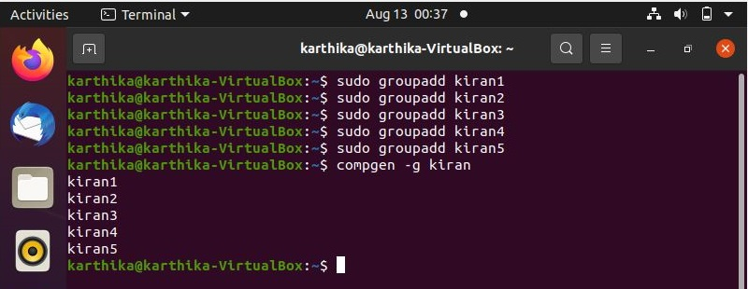

1. groups

In linux, there can be multiple users(those who use/operate the system), and groups are nothing but the collection of users. Groups make it easy to manage users with the same security and access privileges. A user can be part of different groups.

**IMPORTANT POINTS:**

* Groups command prints the names of the primary and any supplementary groups for each given username, or the current process if no names are given.
* If more than one name is given, the name of each user is printed before the list of that user’s groups and the username is separated from the group list by a colon.

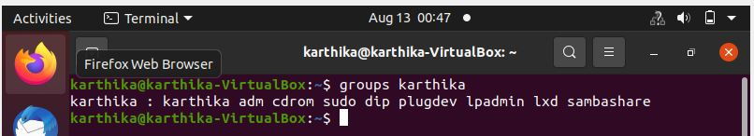

1. groupdel

groupdel command is used to delete a existing group. It will delete all entry that refers to the group, modifies the system account files, and it is handled by superuser or root user.

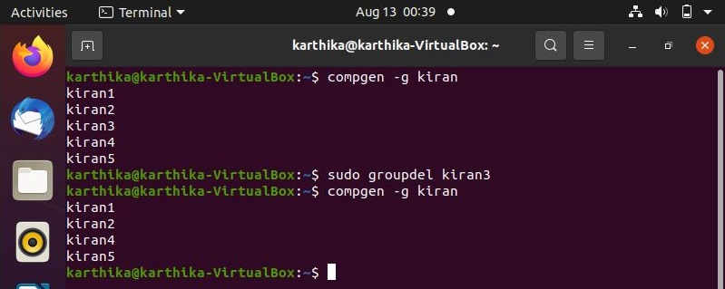

1. groupmod

**groupmod** command in Linux is used to modify or change the existing group on Linux system. It can be handled by superuser or root user. Basically, it modifies a group definition on the system by modifying the right entry in the database of the group.

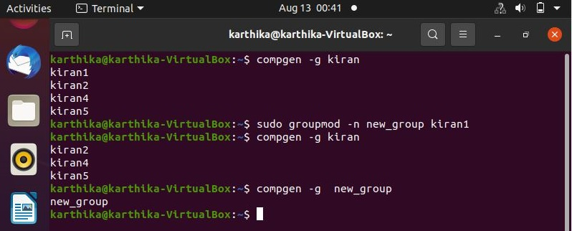

1. chmod

In Unix-like operating systems, the **chmod** command is used to change the access mode of a file.  
The name is an abbreviation of **change mode**.

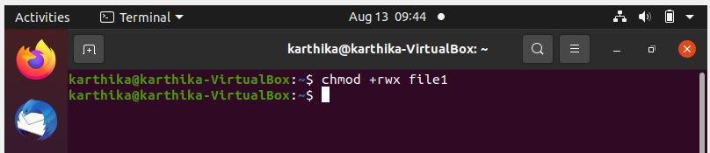

1. chown

**chown** command is used to change the file Owner or group. Whenever you want to change ownership you can use chown command.



1. id

**id command** in Linux is used to find out user and group names and numeric ID’s (UID or group ID) of the current user or any other user in the server.

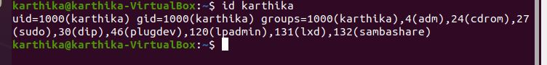

1. ps

Abbreviation for **“Process Status”.** ps command is used to list the currently running processes and their PIDs along with some other information depends on different options. It reads the process information from the virtual files in **/proc** file-system. /proc contains virtual files, this is the reason it’s referred as a virtual file system.

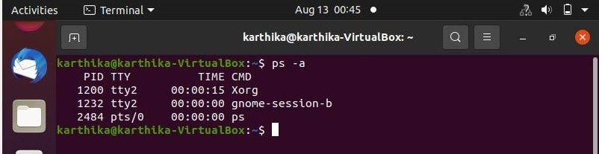

1. top

**top** command is used to show the Linux processes. It provides a dynamic real-time view of the running system. Usually, this command shows the summary information of the system and the list of processes or threads which are currently managed by the Linux Kernel.

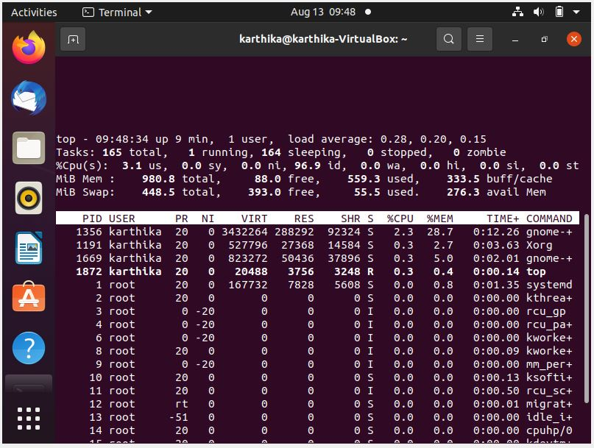

BASIC LINUX COMMANDS

1. wc

wc stands for **word count**. As the name implies, it is mainly used for counting purpose. It is used to find out number of lines, word count, byte and characters count in the files specified in the file arguments.

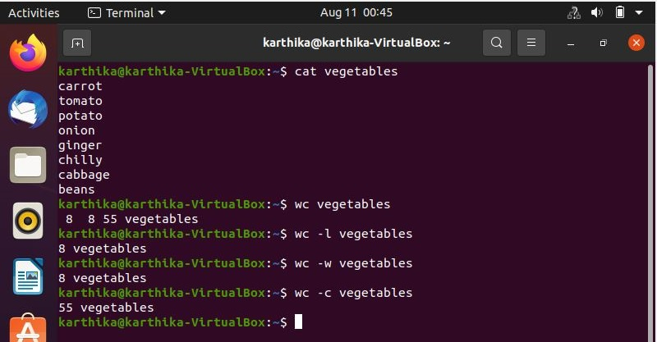

1. tar

The Linux ‘tar’ stands for tape archive, is used to create Archive and extract the Archive files. tar command in Linux is one of the important command which provides archiving functionality in Linux. We can use Linux tar command to create compressed or uncompressed Archive files and also maintain and modify them.

**OPTIONS:**

**-c :** Creates Archive   
**-x :** Extract the archive   
**-f :** creates archive with given filename   
**-t :** displays or lists files in archived file   
**-u :** archives and adds to an existing archive file   
**-v :** Displays Verbose Information   
**-A :** Concatenates the archive files   
**-z :** zip, tells tar command that creates tar file using gzip   
**-j :** filter archive tar file using tbzip   
**-W :** Verify a archive file   
**-r :** update or add file or directory in already existed .tar file

**Tar command**

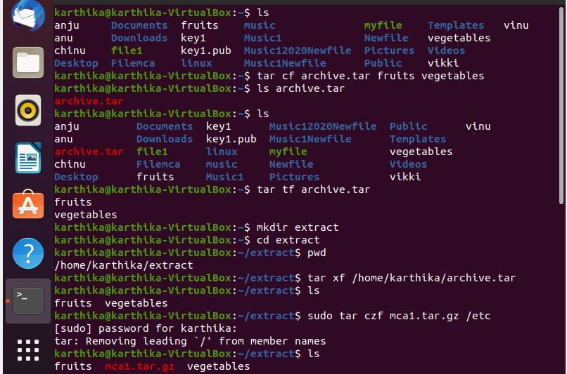

**Compressing files using gz,bz2, xz**

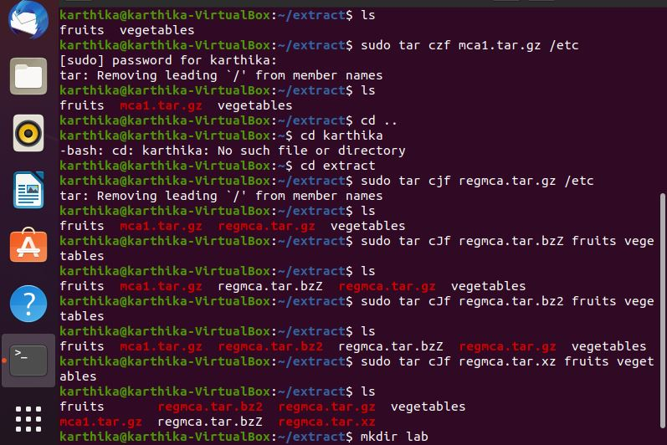

**Extracting using gz**

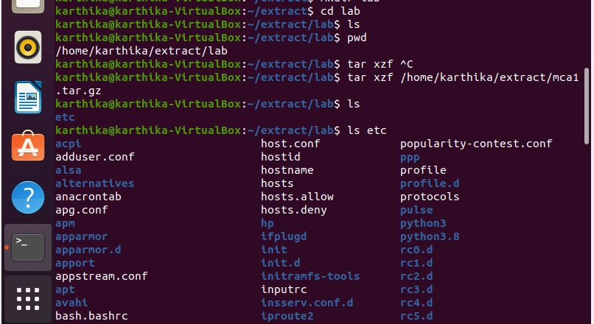

**Extracting using xz**

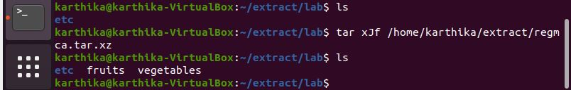

**Extracting using bz2**

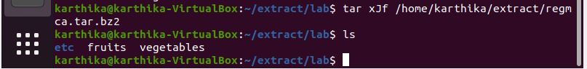

1. expr

The **expr** command in Unix evaluates a given expression and displays its corresponding output.

* Basic operations like addition, subtraction, multiplication, division, and modulus on integers.
* Evaluating regular expressions, string operations like substring, length of strings etc.

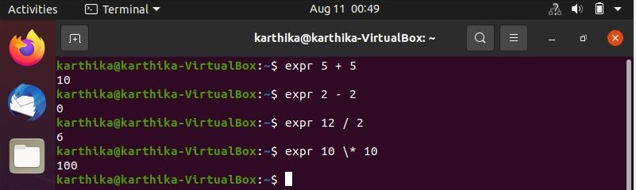

1. redirection and piping

Pipe is used to combine two or more commands, and in this, the output of one command acts as input to another command, and this command’s output may act as input to the next command and so on.

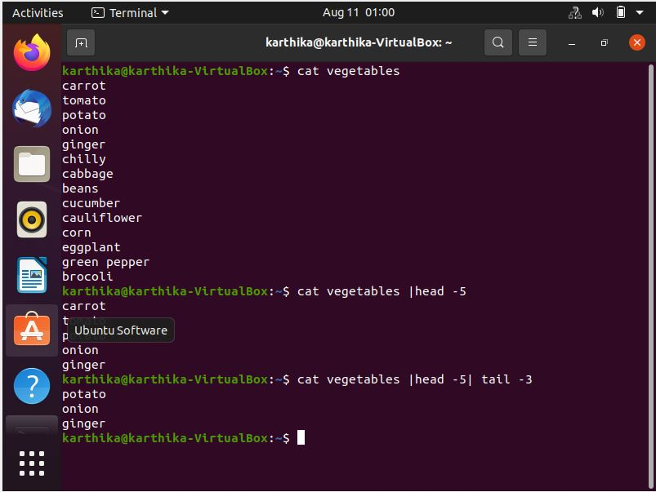

1. ssh

ssh stands for **“Secure Shell”**. It is a protocol used to securely connect to a remote server/system. ssh is secure in the sense that it transfers the data in encrypted form between the host and the client. It transfers inputs from the client to the host and relays back the output. ssh runs at TCP/IP port 22.

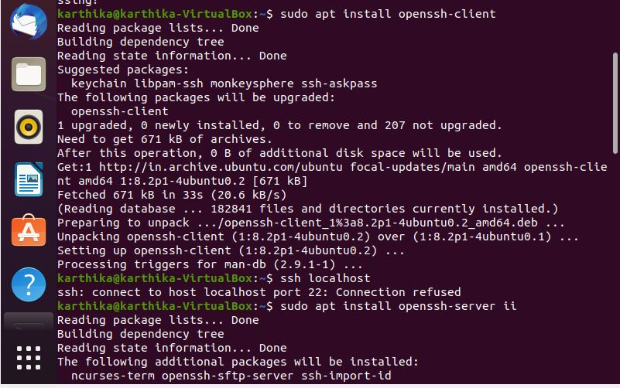

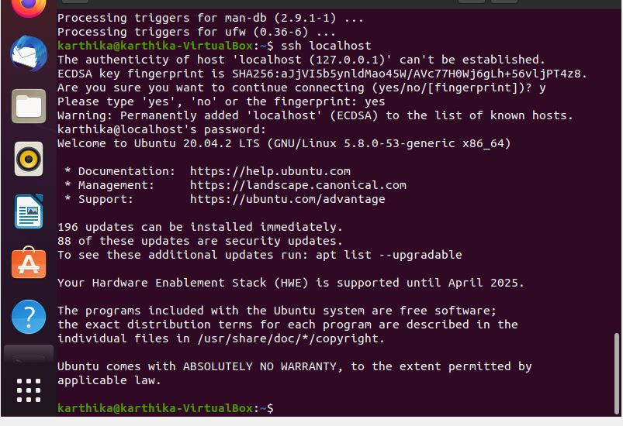

1. scp

**scp** (secure copy) command in Linux system is used to copy file(s) between servers in a secure way.

1. ssh-keygen

Use the ssh-keygen command to generate a public/private authentication key pair. Authentication keys allow a user to connect to a remote system without supplying a password. Keys must be generated for each user separately. If you generate key pairs as the root user, only the root can use the keys.

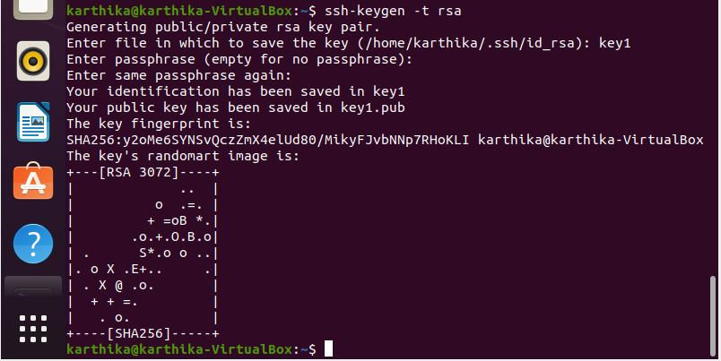

1. ssh-copy-id

* The ssh-copy-id command is a simple tool that allows you to install an SSH key on a remote server’s authorized keys.
* This command facilitates SSH key login, which removes the need for a password for each login, thus ensuring a password-less, automatic login process.
* The ssh-copy-id command is part of OpenSSH, a tool for performing remote system administrations using encrypted SSH connections.

**NETWORK COMMANDS**

**Q1.** Ping, route, traceroute, nslookup, IpConfig, NetStat

LINUX

1. Ping

ping is the primary TCP/IP command used to troubleshoot connectivity, reachability, and name resolution. Used without parameters, this command displays Help content.

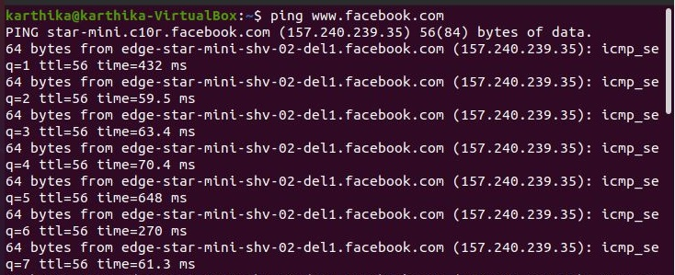

1. Traceroute

Traceroute is a network diagnostic tool used to track in real-time the pathway taken by a packet on an IP network from source to destination, reporting the IP addresses of all the routers it pinged in between. Traceroute also records the time taken for each hop the packet makes during its route to the destination.

The difference between **tracert(windows)** and **traceroute(linux)** is that: tracert(windows) will only use ICMP echo requests. traceroute(linux) [and somewhat dependent on linux distro] default to UDP echo requests.

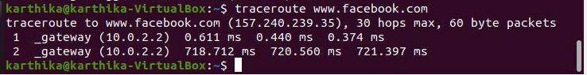

1. Nslookup

Nslookup (stands for “Name Server Lookup”) is a **useful command for getting information from DNS server**. It is a network administration tool for querying the Domain Name System (DNS) to obtain domain name or IP address mapping or any other specific DNS record.

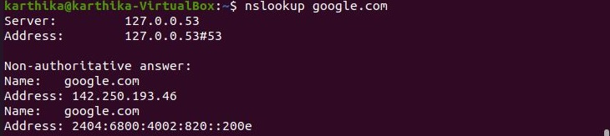

1. netstat -l

The netstat command symbolically **displays the contents of various network-related data structures for active connections**. The Interval parameter, which is specified in seconds, continuously displays information regarding packet traffic on the configured network interfaces.

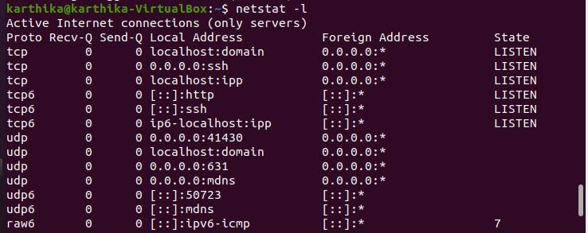

1. route

The route command allows **you to make manual entries into the network routing tables**. The route command distinguishes between routes to hosts and routes to networks by interpreting the network address of the Destination variable, which can be specified either by symbolic name or numeric address.

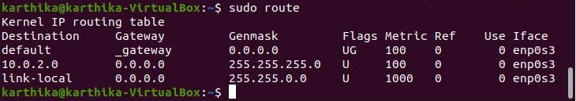

1. ipconfig

* ipconfig (standing for "Internet Protocol configuration") is a console application program of some computer operating systems that displays all current TCP/IP network configuration values and refreshes Dynamic Host Configuration Protocol (DHCP) and Domain Name System (DNS) settings.
* Ifconfig (interface configuration) command is used to configure the kernel-resident network interfaces. It is used at the boot time to set up the interfaces as necessary. After that, it is usually used when needed during debugging or when you need system tuning. Also, this command is used to assign the IP address and netmask to an interface or to enable or disable a given interface.
* The ifconfig command is supported by Unix-based operating systems. Functionality: The ipconfig command **displays all the currently connected network interfaces whether they are active or not**. On the other hand, the ifconfig command displays only the enabled network interfaces that are connected to the system.

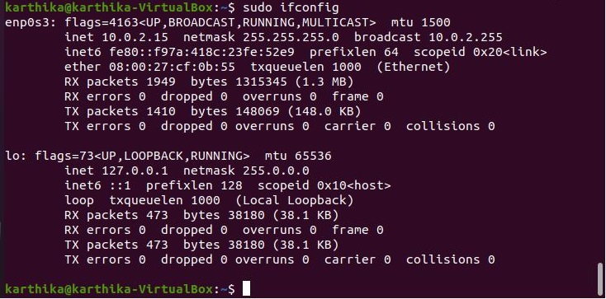

**WINDOWS**

1. ping

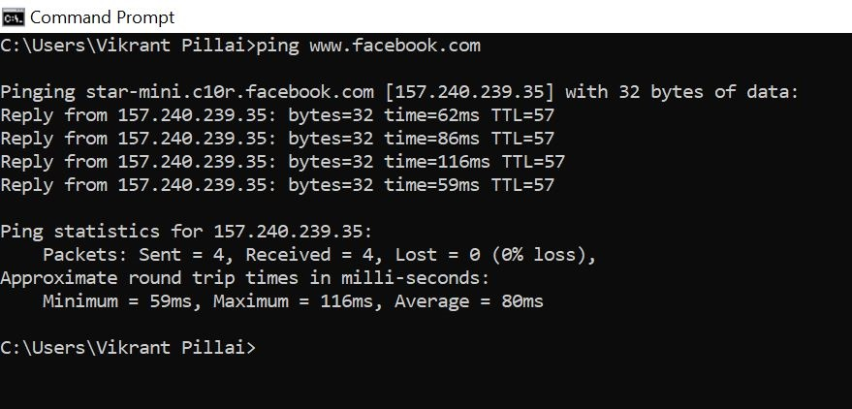

1. route

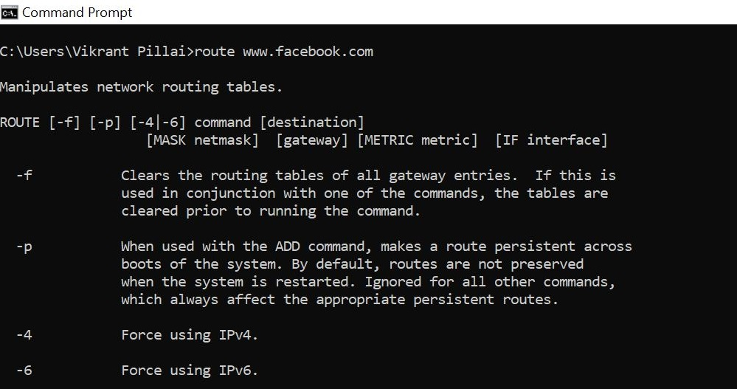

1. tracert

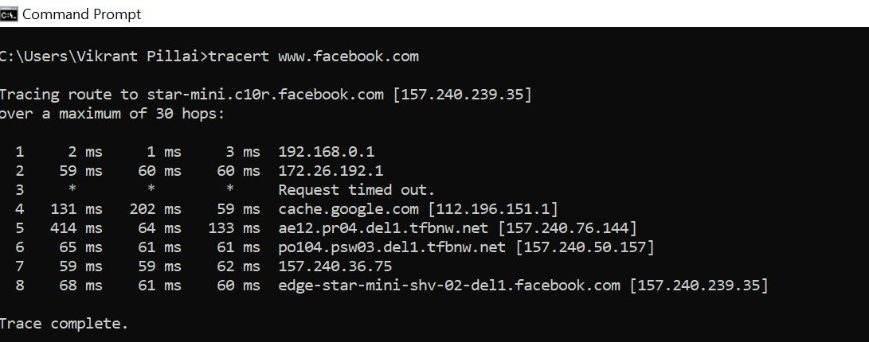

1. netstat

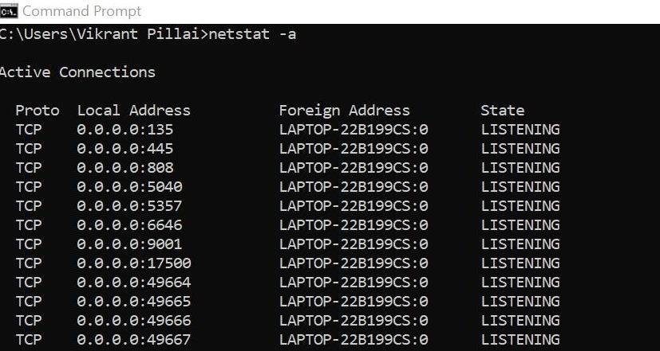

1. ipconfig

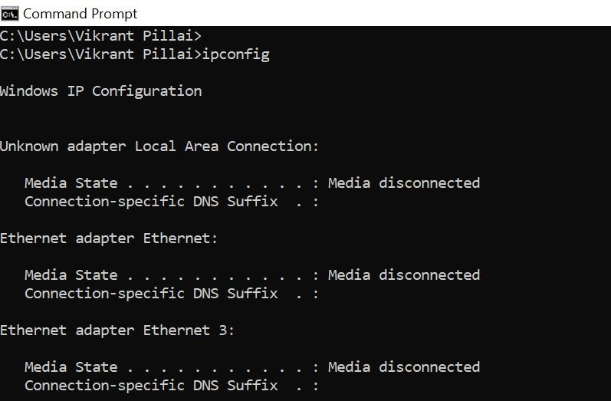

1. nslookup

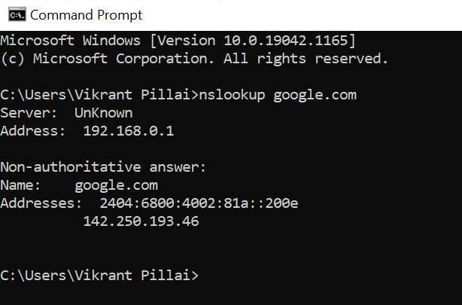

**Q2.** Identify and perform 5 more network commands

1. hostname

A very simple command that displays the host name of your machine. This is much quicker than going to the controlpanel>system route.

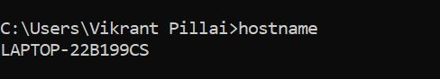

1. getmac

Another very simple command that shows the MAC address of your network interfaces.

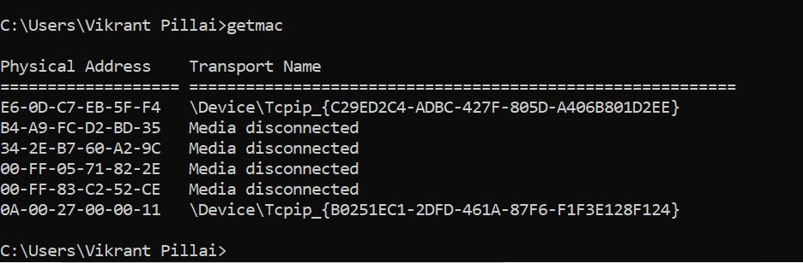

1. arp

 This is used for showing the**address resolution cache**. This command must be used with a command line switch **arp -a** is the most common.

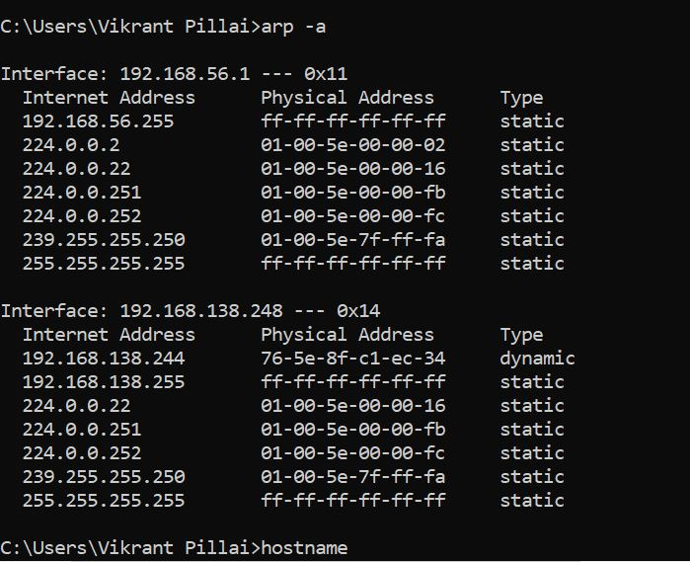

1. nbtstat

The nbtstat command is **a diagnostic tool for NetBIOS over TCP/IP**. Its primary design is to help troubleshoot NetBIOS name resolution problems. The command is included in several versions of Microsoft Windows. ... When a network is functioning normally, NetBIOS over TCP/IP (NetBT) resolves NetBIOS names to IP addresses.

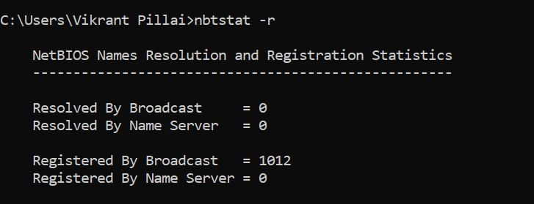

1. path ping

The pathping command which provides a combination of the best aspects of Tracert and Ping. This command takes 300 seconds to gather statistics and then returns reports on latency and packet loss statistics at intermediate hops between the source and the target in more detail than those reports provided by Ping or Tracert commands.

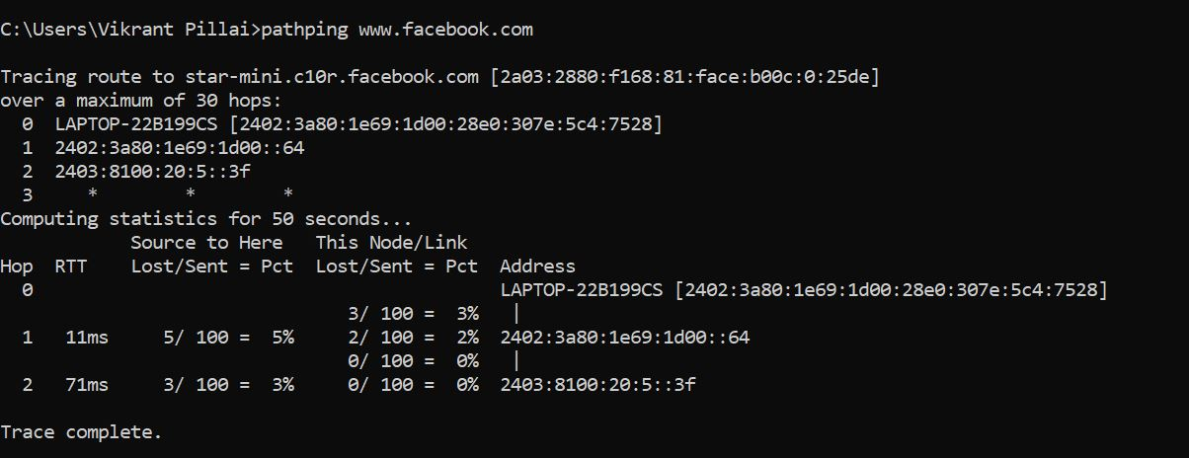

**LAMP INSTALLATION STEPS**

1. Install Apache

**Update your system**

* 1. sudo apt update

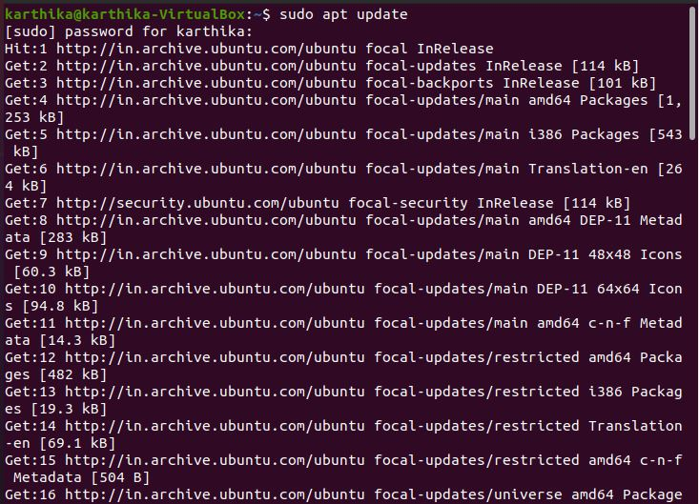

**Install Apache using apt:**

* 1. sudo apt install apache2

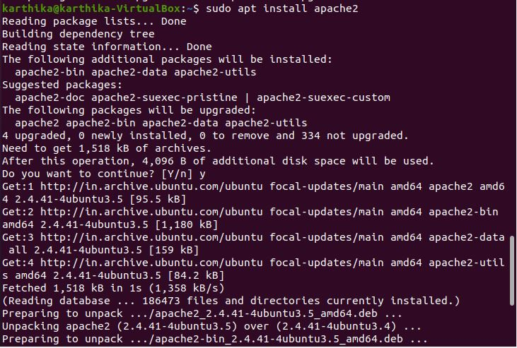

**Confirm that Apache is now running with the following command:**

* 1. sudo systemctl status apache2

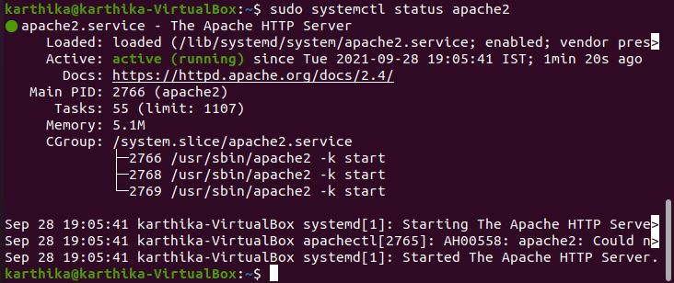

**Once installed, test by accessing your server’s IP in your browser:**

http://youripaddress

* 1. ( find out your ip address using iffconfig)

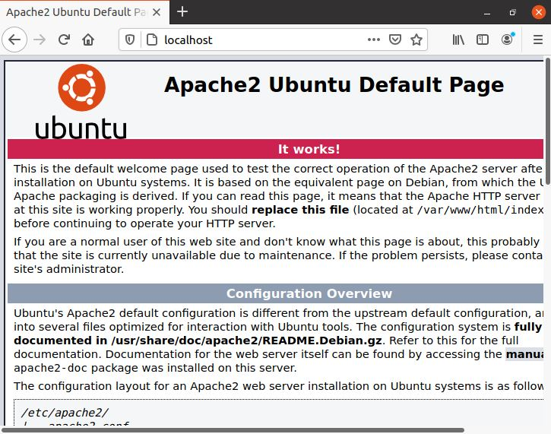

1. Install MariaDB

**To install mariadb**

* 1. sudo apt install mariadb-server mariadb-client

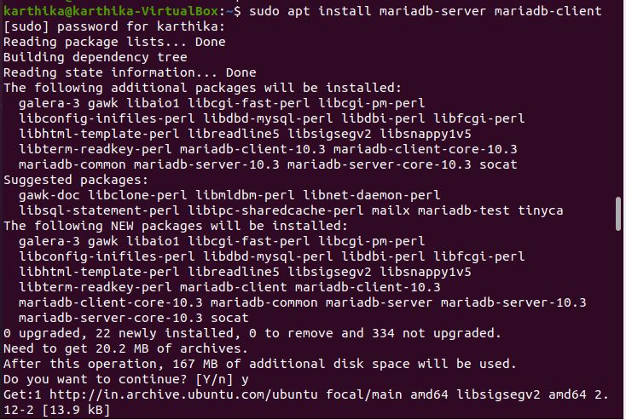

* 1. sudo systemctl status mysql

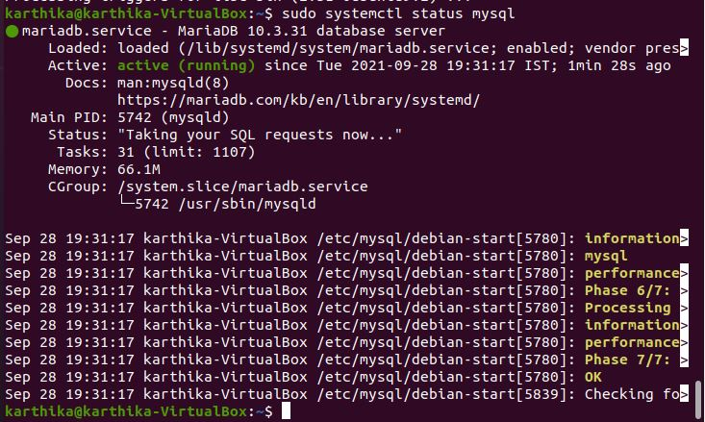

**To secure mariadb**

* 1. sudo mysql_secure_installation

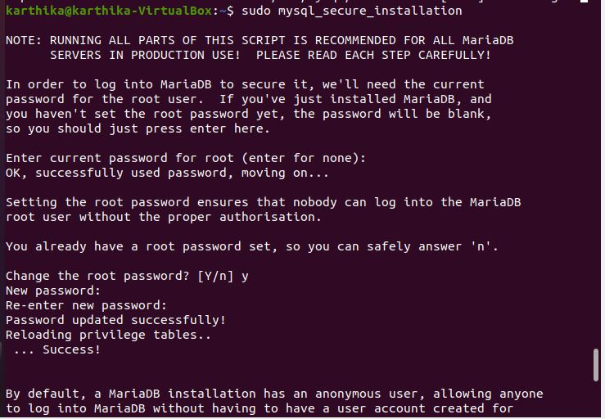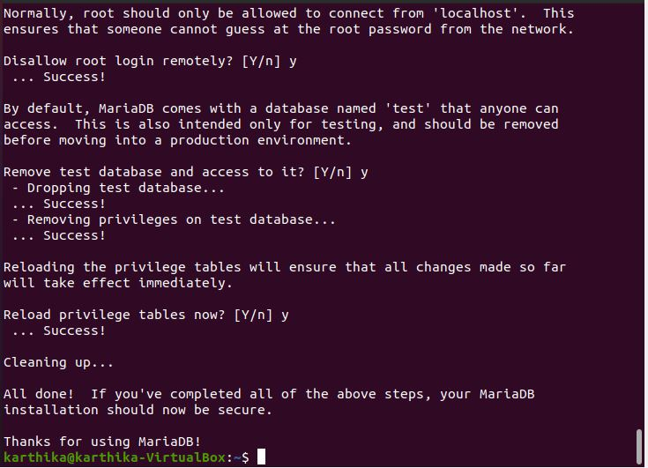

1. Install PHP and commonly used modules
   1. sudo apt install php libapache2-mod-php php-opcache php-cli php-gd php-curl php-mysql

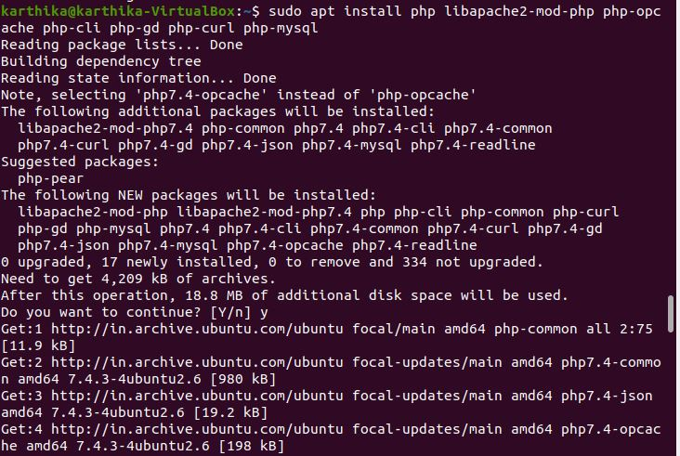

**Restart apache2**

* 1. sudo systemctl restart apache2



**Test PHP Processing on Web Server**

* 1. sudo nano /var/www/html/phpinfo.php



Inside the file, type in the valid PHP code:

<?php

phpinfo ();

?>

Press CTRL + X to save and close the file. Press y and ENTER to confirm

Open a browser and type in your IP address/phpinfo.php

<http://127.0.0.1/phpinfo.php>

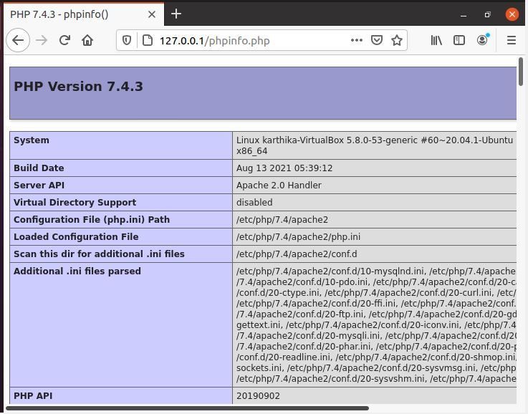

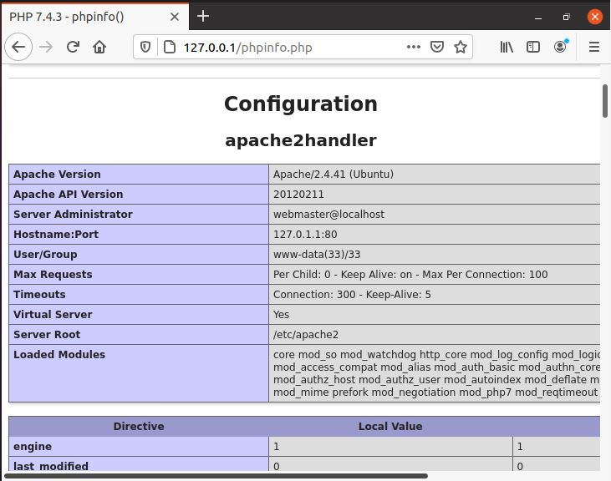

1. Install phpMyAdmin

**To install phpMyAdmin**

* 1. sudo apt install phpmyadmin php-mbstring php-zip php-gd php-json php-curl

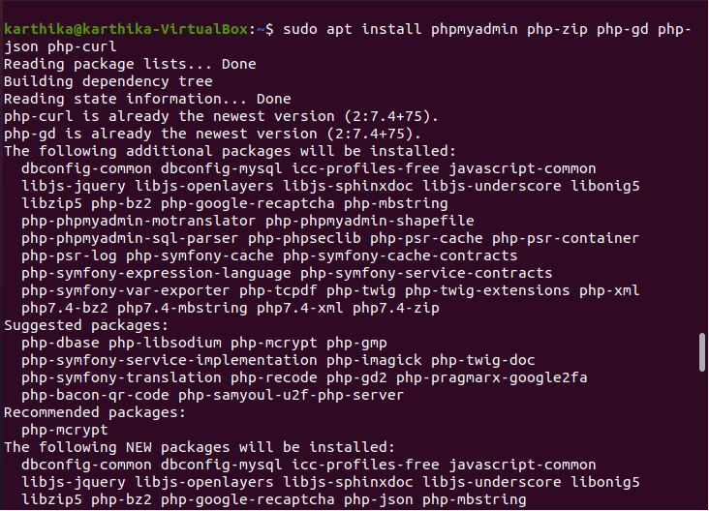

**Restart apache2**

* 1. sudo systemctl restart apache2

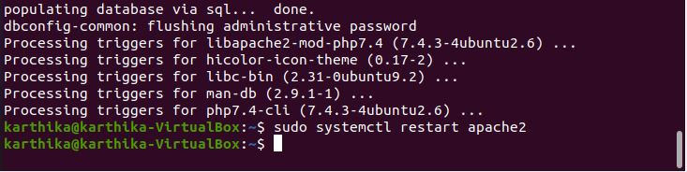

Open a browser: <http://localhost/phpmyadmin>

username: root

password: your password

If phpmyadmin page not found:

nano /etc/apache2/apache2.conf

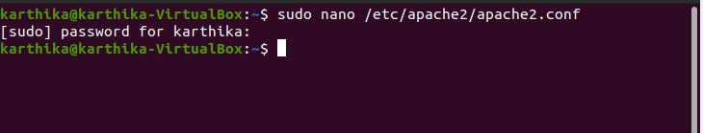

Add this line to last of the file.

“Include /etc/phpmyadmin/apache.conf”

Press CTRL + X to save and close the file. Press y and ENTER to confirm

Restart apache2 - now try : http://localhost/phpmyadmin

sudo systemctl restart apache2

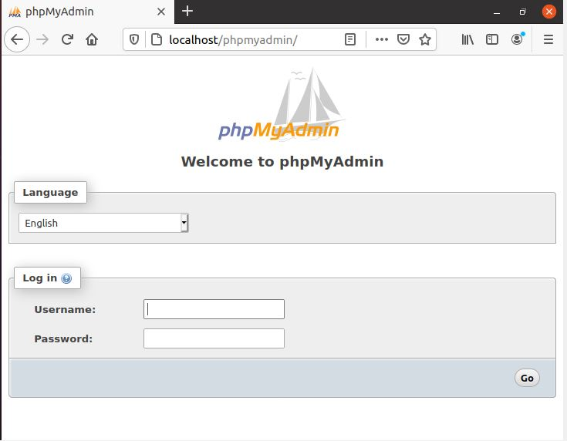

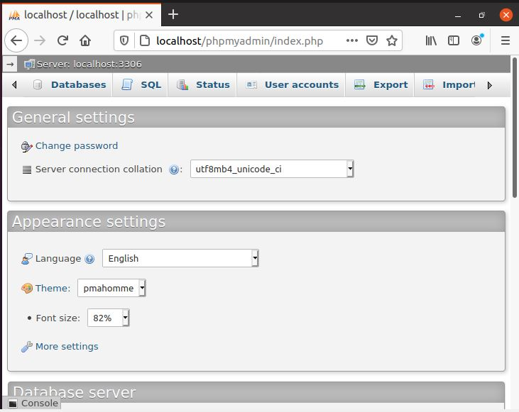

**ANSIBLE**

**WHAT IS ANSIBLE?**

* Ansible is an open source IT automation engine that automates [provisioning](https://www.redhat.com/en/topics/automation/what-is-provisioning), [configuration management](https://www.redhat.com/en/topics/automation/what-is-configuration-management), application deployment, [orchestration](https://www.redhat.com/en/topics/automation/what-is-orchestration), and many other IT processes.
* Use Ansible automation to install software, automate daily tasks, provision infrastructure, improve security and compliance, patch systems, and share automation across your organization.
* Ansible works by connecting to your nodes and pushing out small programs, called modules to them. Modules are used to accomplish automation tasks in Ansible.
* These programs are written to be resource models of the desired state of the system. Ansible then executes these modules and removes them when finished.
* Without modules, you’d have to rely on ad-hoc commands and scripting to accomplish tasks.
* Ansible is agentless, which means the nodes it manages do not require any software to be installed on them.
* Ansible reads information about which machines you want to manage from your inventory. Ansible has a default inventory file, but you can create your own and define which servers you want Ansible to manage.
* Ansible uses [SSH protocol](https://www.ssh.com/ssh/protocol/) to connect to servers and run tasks. By default, Ansible uses SSH keys with ssh-agent and connects to remote machines using your current username. Root logins are not required. You can log in as any user, and then su or sudo to any user.

**Ansible Playbooks:**

* **Ansible Playbooks** are the files where Ansible code is written. These files are written in the language, **YAML**, which is a funny acronym for, “YAML Ain’t no Markup Language.”
* Playbooks contain one or more Plays. **Plays** map a group of computers to a few well-defined roles known as Tasks. **Tasks** can be defined as Ansible scripts.

**YAML**

YAML is a simple language that consists of key-value pairs. While not mandatory, --- marks the beginning of a YAML program, and ... marks the end.

YAML also allows the creation of lists. Lists can be created with the - symbol inside variables to define elements.

## Orchestration with Ansible:

* In general, automation refers to automating a single task. This is different from orchestration, which is how you can automate a process or workflow that involves many steps across multiple disparate systems.
* [Cloud orchestration](https://www.redhat.com/en/topics/automation/what-is-cloud-automation) can be used to provision or deploy servers, assign storage capacity, create virtual machines, and manage networking, among other tasks. There are many different orchestration tools that can help you with cloud orchestration. Ansible is one option.
* Server configuration and management and application deployments can also be orchestrated with a tool like Ansible.

**INSTALLATION:**

1. Sudo apt-get install ansible

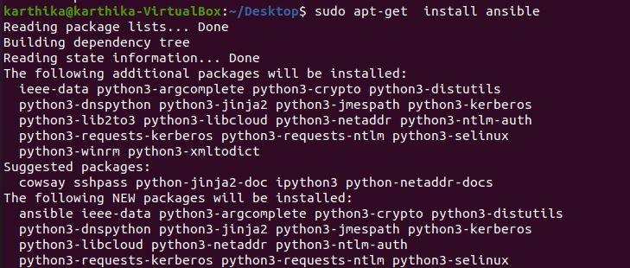

1. ansible --version

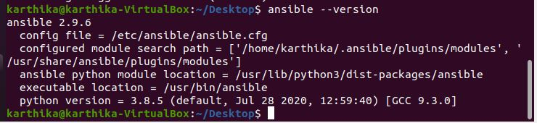

**TCPDUMP**

**1. Tcpdump installation**

* Sudo apt install tcpdump
* Sudo tcpdump
* Tcpdump -D
* tcpdump-i enp0s3
* sudo tcpdump –c 5
* Sudo tcpdump –i enp0s3 –c 5 port 80

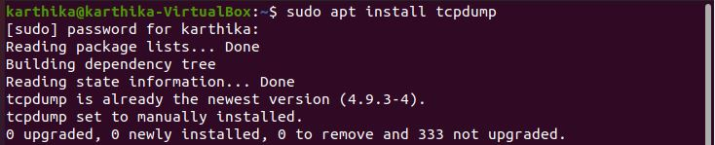

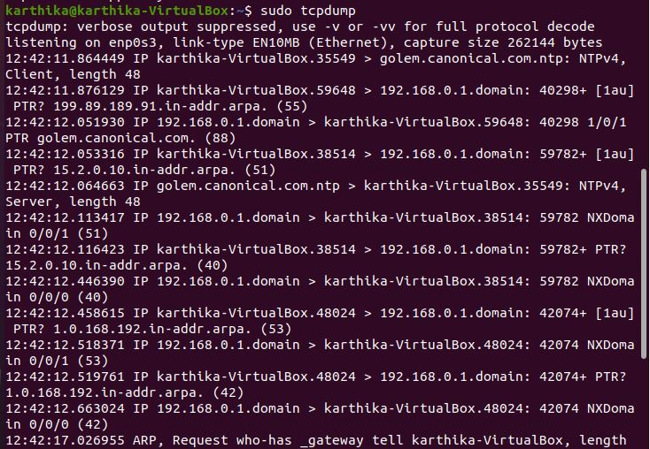

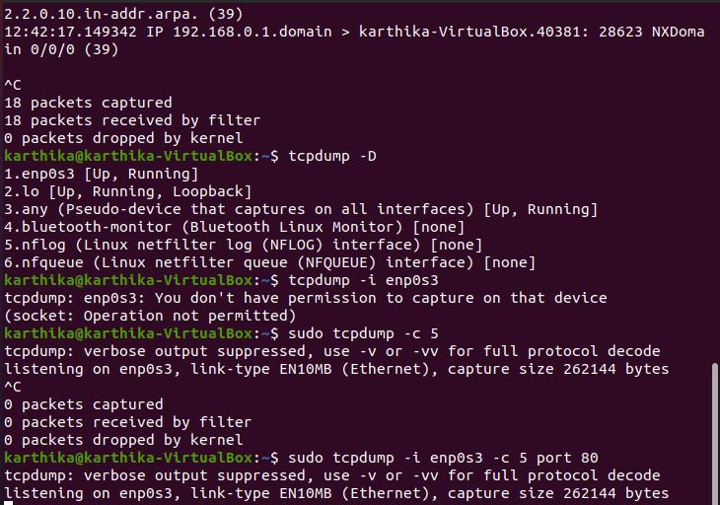

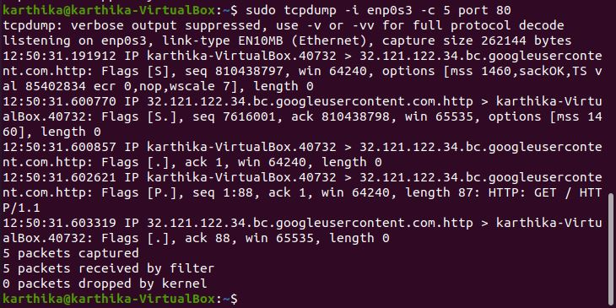

* tcpdump 10.0.2.15
* tcpdump –I eth1 icmp

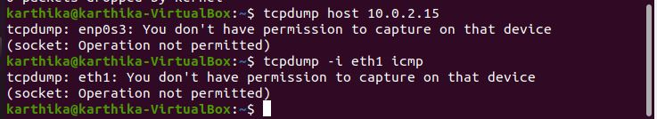

* Sudo tcpdump –n –i enp0s3 –c 10 –w icmp.pcap

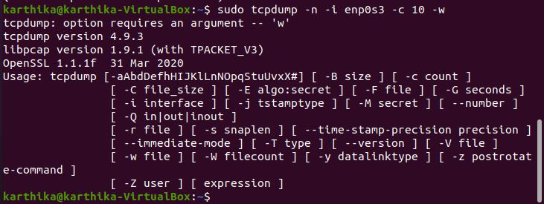

**SHELL SCRIPTING**

**Q1**. Write a shell script to ask your name, and college name and print it on the screen.

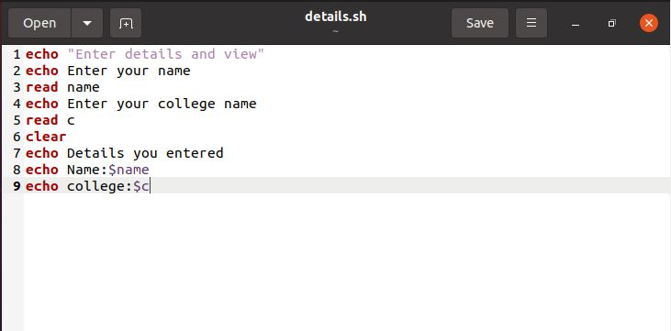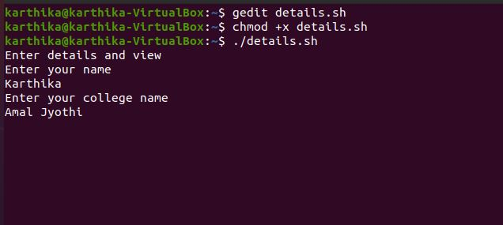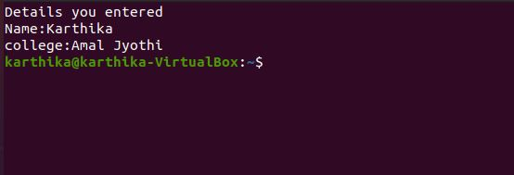

**Q2.** Write a shell script to set a value for a variable and display it on command line interface.

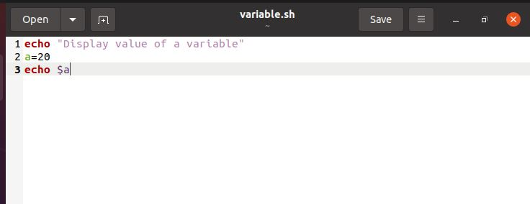

**Q3.** Write a shell script to perform addition, substation, multiplication, division with two numbers that is accepted from user.

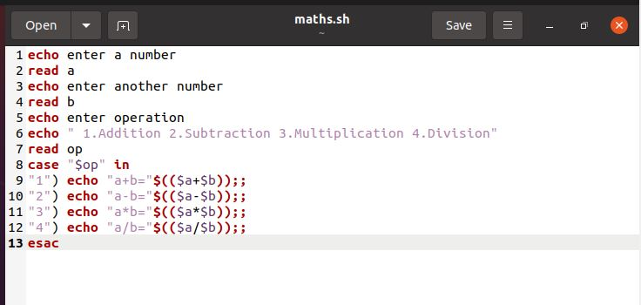

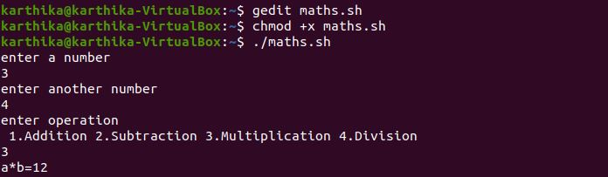

**Q4.** Write a shell script to check the value of a given number and display whether the number is found or not.

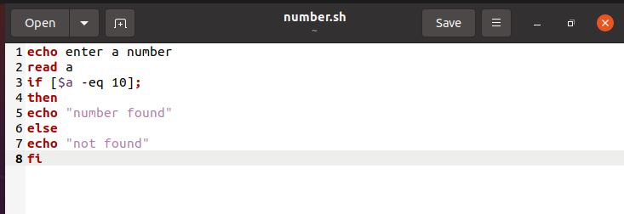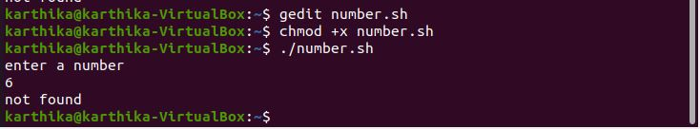

**Q5.** Write a shell script to display current date, calendar.

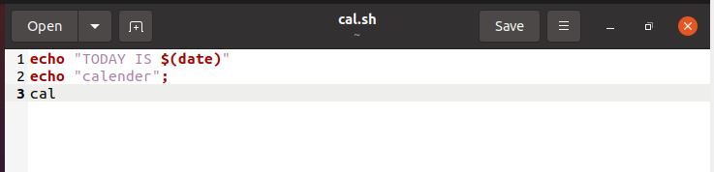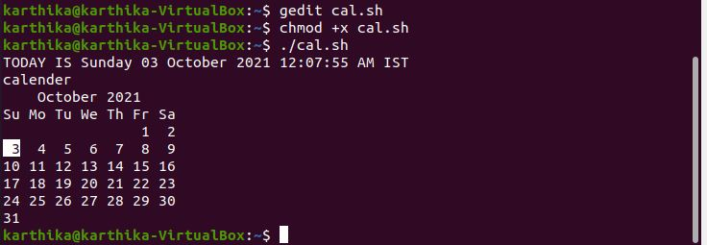

**Q6.** Write a shell script to check a number is even or odd. #!/bin/bash

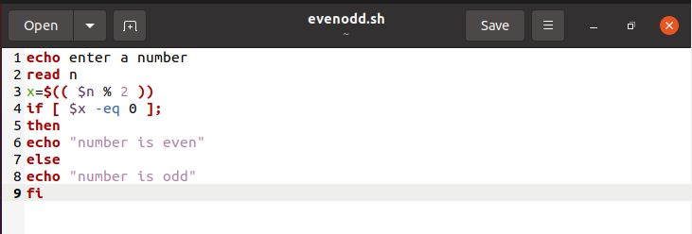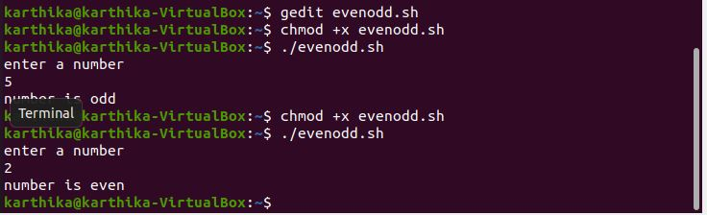

**Q7.** Write a shell script to check a number is greater than, less than or equal to another number.

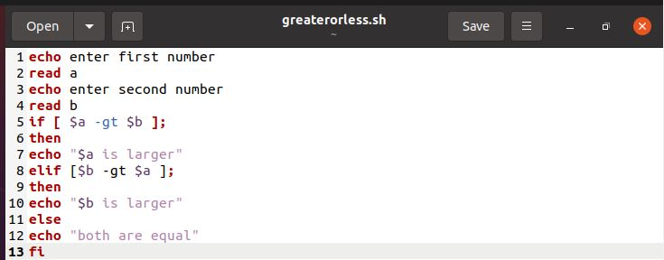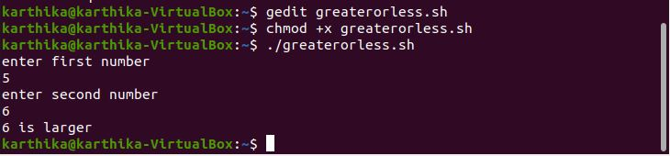

**Q8.** Write a shell script to find the sum of first 10 numbers.

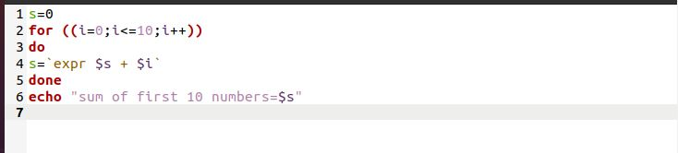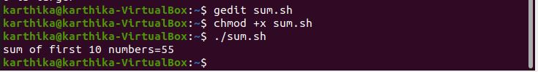

**Q9.** Write a shell script to find the sum, the average and the product of the four integers entered.

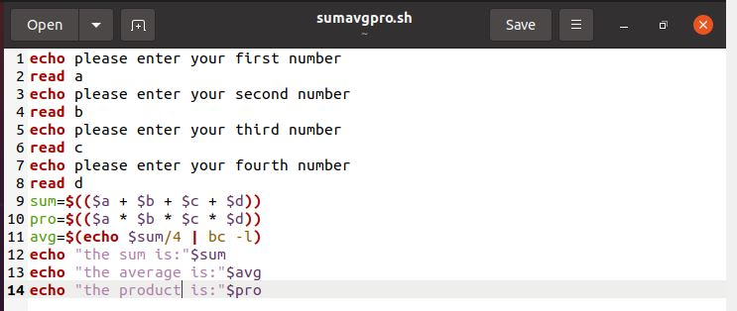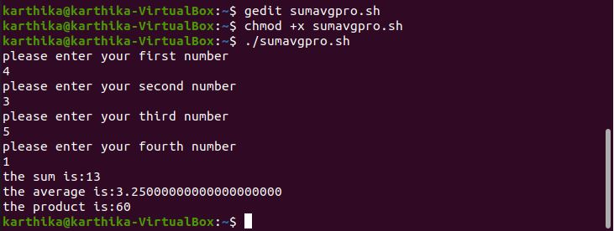

**Q10.** Write a shell script to find the smallest of three numbers.

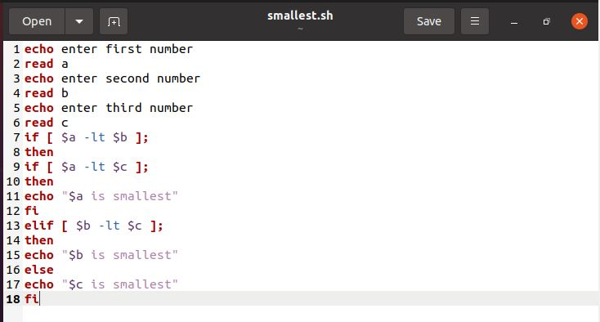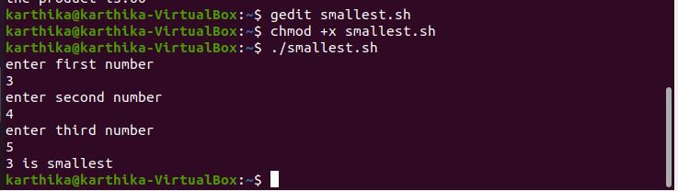

**Q11.** Write a shell program to find factorial of given number.

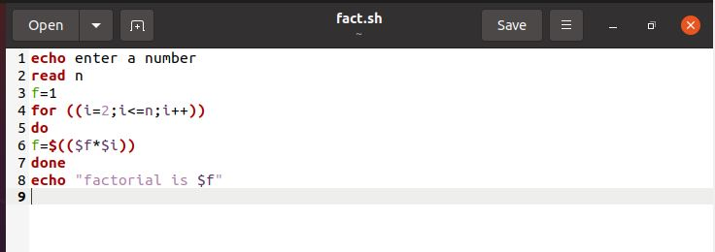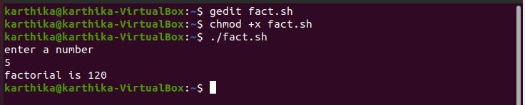

**Q12.** Write a shell program to check a number is palindrome or not.

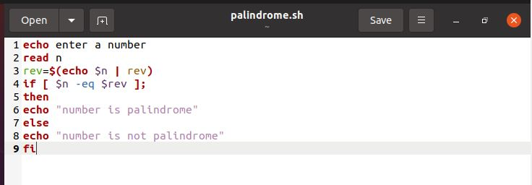

**Q13.** Write a shell script to find the average of the numbers entered in command line.

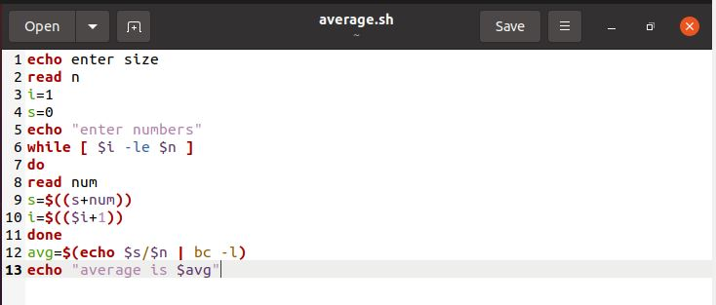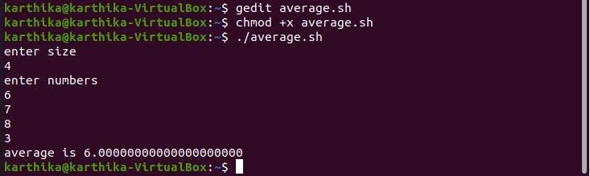

**Q14.** Write a shell program to find the sum of all the digits in a number.

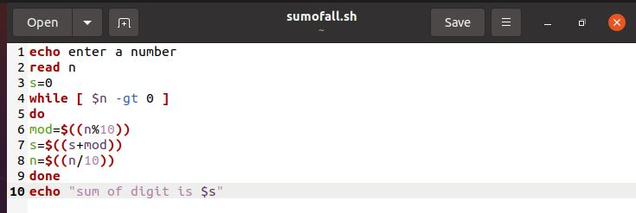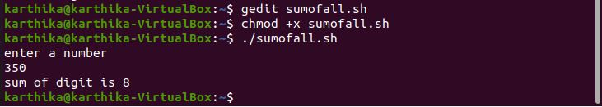

**Q15.** Write a shell Script to check whether given year is leap year or not.

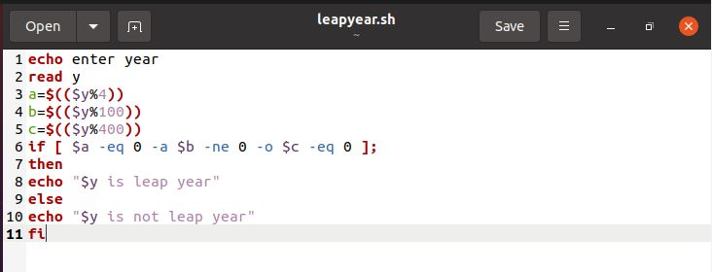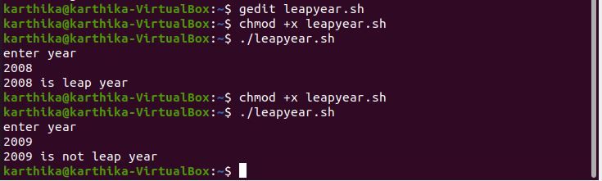

**STEP-I**

**Docker installation on Windows 10**

Download Docker desktop Installer for Windows from https://desktop.docker.com/win/main/amd64/Docker%20Desktop%20Installer.exe



**STEP-II**

Open the .exe file and follow the steps after clicking install button.

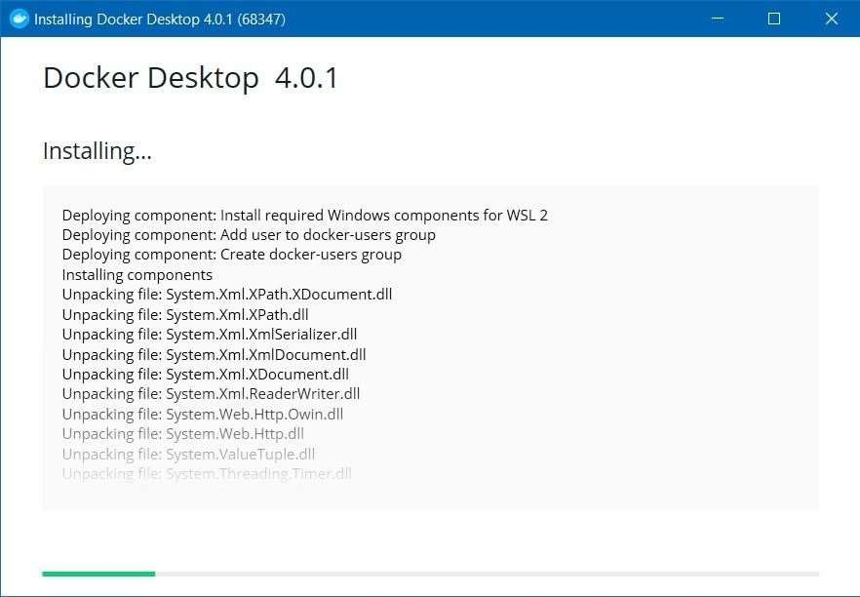

**Step-III**

Once installed go to programs and features and click turn on windows features on or off

Scroll to the bottom and select windows subsystem for Linux

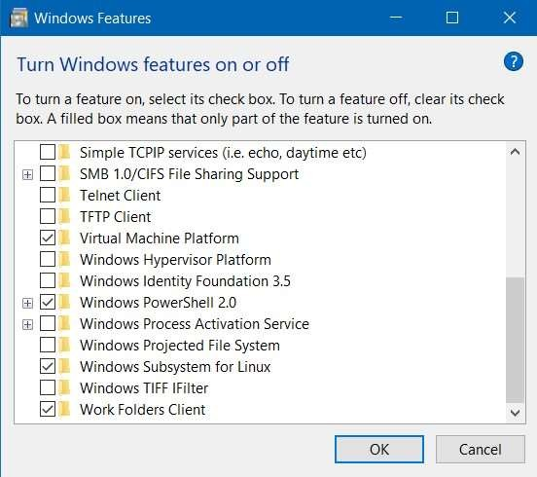

**STEP-IV**

If any WSL 2 error occurs download windows subsystem for linux update package and install the .exe file, after the installation restart the windows device.

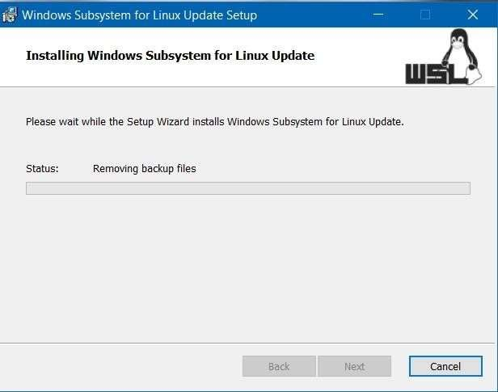

**STEP-V**

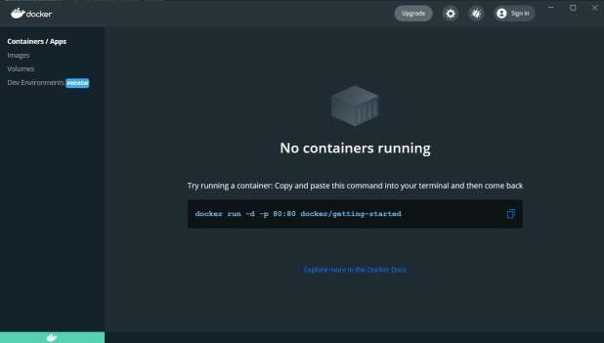Once installed, open the docker desktop app, and signin using the dockerID

**STEP-VI**

Now pull any image from docker hub using the docker pull command in the command prompt (eg: docker pull ubuntu)

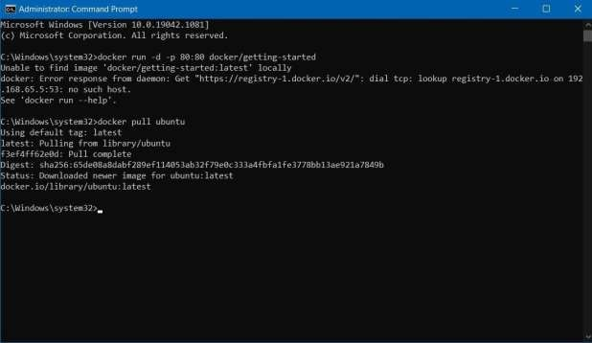

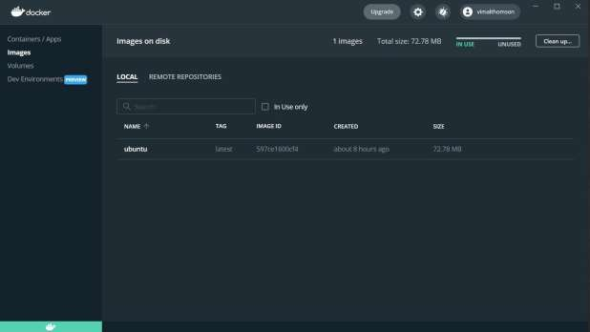Now in the images tab an image of ubuntu will be displayed, we can run the ubuntu instance using the cl

**WIRESHARK INSTALLATION**

1. Command: sudo apt-get install wireshark

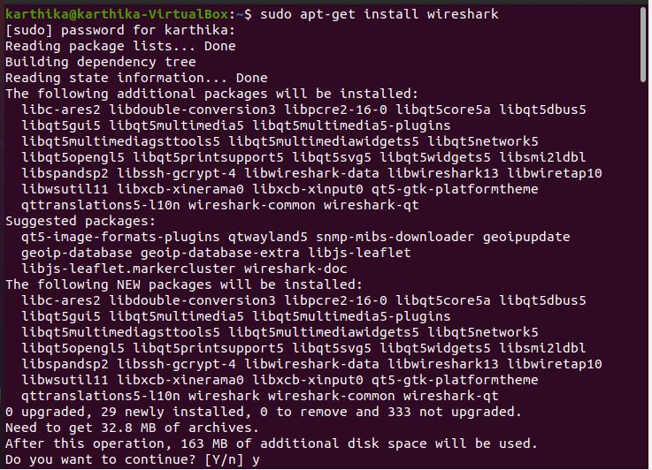

1. Command: sudo dkpg-reconfigure wireshark-common



1. 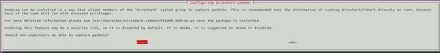 Command: Select Yes and press enter
2. Open wireshark from the applist

